**1. INTRODUCTION**

This system is basically concerned with the reservation and cancellation of railway tickets to the passengers. The need of this system arose because as is the known fact that India has the largest railway network in the whole of the world and to handle it manually is quite a tough job. The long distance road network is very poorly developed in most parts of India. Bulk of long distance traffic is carried by the Indian Railway as a result Indian railways. Therefore forms a backbone of public transport in India. The efficiency of the railway will increase result of computerization due to dramatic reduction in communication time among geographically dispersed offices. For the reservation of the ticket a person go to ticket counter of the railway reservation office and expend its valuable time in standing queue. Now to save that time we have a facility of Online Reservation now we can book cancel or search other train information just by click on computer and phones.

**1.1 GOAL OF PROJECT**

The main objective of this system is to reduce the consumption of time during maintaining the records of Railway Reservation System. Separate divisions are provide to maintain the records Passenger etc.

Our software will overcome all these Safe, efficient, reliable, and sustainable movement of persons and goods over time and space.

**1.2 SCOPE OF THE PROJECT**

* To reduce complexity of existing system.
* Effective management of time.
* To make work easy, simple and error free.
* Effective utilization of available resource.
* To enhance the efficiency and diversification of services activities.
* User friendly.
* Interactive graphical user interface.

The scope of project define the project feasibility the technology, finance , me and resources best define in technology weather the defects can be reduced in the project and up which level financially, weather the overall project cost is affordable. Time describe the weather the projection finishing point will be achieve on time or before time resources required should be available at the rate of cost and time.

**2. LITERATURE SURVEY**

Railway is one of the important infrastructures and mean of concern for the growth of any country.

The problems that arise due to unconditional transportation are uncertainity of waiting time due to taking ticket from counter and any other issue live abnormal conditioning. Now a day the safety and privacy becomes main concern for private and public vehicles while travelling.

**2.1 EXISTING SYSTEM**

Today all the work at the time of taking transport services of the passenger is done manually by ink and paper, which is very slow and consuming much efforts and time.

Since the numbers of passenger is growing, and they have to handle records of all the passenger, it is facing a little bit problems in maintaining the records of passenger and other details.

It is required to Design of a Computerized Railway Reservation System, to speed up and make it easy to use system.

**2.2 PROPOSED SYSTEM**

The online railway ticket reservation system aims to develop a web application which aims at providing trains details, trains availability, as well as the facility to book ticket in online for customers. So, we thought of developing a web based application which would provide the users all these facilities from his terminal only as well as help them in booking their tickets. The Application was to be divided into two parts namely the user part, and the administrator part. And each of these has their corresponding features. We decided to give the name of the website “ RAILWAY RESEVATION SYSTEM”. The online railway ticket reservation system is developed using ASP.NET with C# as the backend in the .NET Framework.

**2.2 FEASIBILITY STUDY**

In other words the objective of the present Railway Reservation System software are:

* Simple database is maintained.
* Easy operation for the operator of the System.
* Faster execution & maintaining the records.
* User interface are user friendly and attractive, it takes very less time for the operator to get use-to with the system.
  1. **TOOLS AND TECHNOLOGIES USED**

**2.3.1 ASP.NET**

* ASP stands for Active Server Pages.
* ASP is a development framework for building web pages.

The ASP Technology

* ASP and ASP.NET are server side technologies.
* Both technologies enable computer code to be executed by an Internet server.
* When a browser requests an ASP or ASP.NET file, the ASP engine reads the file, executes any code in the file, and returns the result to the browser.

ASP.NET

ASP.NET was released in 2002 as a successor to Classic ASP.

ASP.NET pages have the extension .aspx and are normally written in C# (C sharp).

ASP.NET 4.6 is the latest official version of ASP.NET.

ASP.NET 5 was expected to be an important redesign of ASP.NET.

However, the development of ASP.NET 5 was stopped in favor of ASP.NET Core.

**2.3.1. HTML**

• HTML is short for HyperText Markup Language.

• Hypertext is simply a piece of text that works as a link.

• Web pages are written in HTML - a simple scripting language.

• Markup Language is a way of writing layout information within documents.

• Basically an HTML document is a plain text file that contains text and nothing else.

• When a browser opens an HTML file, the browser will look for HTML codes in the text and use them to change the layout, insert images, or create links to other pages.

• Since HTML documents are just text files they can be written in even the simplest text editor.

**2.3.2. CSS**

* Cascading Style Sheets, fondly referred to as CSS, is a simple design language intended to simplify the process of making web pages presentable.
* CSS handles the look and feel part of a web page. Using CSS, you can control the color of the text, the style of fonts, the spacing between paragraphs, how columns are size and laid out, what background images or colors are used, as well as a variety of other effects.
* CSS is easy to learn and understand but it provides powerful control over the presentation of an HTML document. Most commonly, CSS is combined with the markup languages HTML or XHTML.

**ADVANTAGES OF CSS:**

* **CSS Saves Time**- You can write CSS once and then reuse same sheet in multiple HTML pages. You can define a style for each HTML element and apply it to as many Web pages as you want.
* **Pages load faster**. - If you are using CSS, you do not need to write HTML tag attributes every time. Just write one CSS rule of a tag and apply to all the occurrences of that tag. So less code means faster download times.
* **Easy maintenance** - To make a global change, simply change the style, and all elements in all the web pages will be updated automatically.
* **Superior styles to HTML** - CSS has a much wider array of attributes than HTML so you can give far better look to your HTML page in comparison of HTML attributes.
* **Multiple Device Compatibility** - Style sheets allow content to be optimized for more than one type of device. By using the same HTML document, different versions of a website can be presented for handheld devices such as PDAs and cell phones or for printing.
* **Global web standards** - Now HTML attributes are being deprecated and it is being recommended to use CSS. So it’s a good idea to start using CSS in all the HTML pages to make them compatible to future browse.

**2.3.3. JAVA SCRIPT**

JavaScript is not a programming language in strict sense. Instead, it is a scripting language because it uses the browser to do the dirty work. If you command an image to be replaced by another one, JavaScript tells the browser to go do it. Because the browser actually does the work, you only need to pull some strings by writing some relatively easy lines of code. That’s what makes JavaScript an easy language to start with. But don’t be fooled by some beginner’s luck: JavaScript can be pretty difficult, too. First of all, despite its simple appearance it is full fledged programming language, it is possible to write quite complex programs in JavaScript. This is rarely necessary when dealing with web pages, but it is possible. This means that there are some complex programming structures that you’ll only understand after protracted studies.

Secondly, and more importantly, there are the browser differences. Though modern web browsers all support JavaScript, there is no sacred law that says they should support exactly the same JavaScript. A large part of this site is devoted to exploring and explaining these browser differences and finding ways to cope with them. So basic JavaScript is easy to learn, but when you start writing advanced scripts browser differences (and occasionally syntactic problems) will creep up.

**2.3.4. SQL SERVER**

* SQL Server is a relational database management system, or RDBMS, developed and marketed by Microsoft.
* Similar to other RDBMS software, SQL Server is built on top of SQL, a standard programming language for interacting with the relational databases.
* SQL server is tied to Transact-SQL, or T-SQL, the Microsoft’s implementation of SQL that adds a set of proprietary programming constructs.
* SQL Server works exclusively on Windows environment for more than 20 years. In 2016, Microsoft made it available on Linux.
* SQL Server 2017 became generally available in October 2016 that ran on both Windows and Linux.

**2.4 HARDWARE AND SOFTWARE REQUIREMENTS**

**HARDWARE REQUIREMENTS:**

* Hardware - Pentium
* Speed - 1.1GHz
* RAM - 1GB
* Hard Disk - 20 GB
* Floppy Drive - 1.44 MB
* Key Board - Standard Windows Keyboard
* Mouse - Two or Three Button Mouse

**SOFTWARE REQUIREMENTS:**

* Operating System - Windows
* Technology - ASP.NET
* Web Technologies - HTML, JAVASCRIPT, CSS,
* IDE - Visual Studio 2012
* Web Server - IIS Express
* Database **-** SQL Server

**3. SOFTWARE REQUIREMENTS SPECIFICATION**

**3.1 FUNCTIONAL REQUIREMENTS**

The main modules involved in this system are:

* Admin
* User
* Booking
* Payment

**3.1.1 Admin**

* Admin can Add Train.
* Admin can Remove Train
* Admin can add, remove and update user details.

**3.1.2 User**

* User can book train ticket.
* User can cancel ticket.
* User can do payment.

**3.1.3 Booking**

* All the booked ticket store in booking table.
* It can be easily update.

**3.1.4 Payment**

* After booking they can do the payment.
* They can do payment by using Paytm..

**3.2 NON FUNCTIONAL REQUIREMENTS**

* **Efficiency Requirement**
  + - When Railway Reservation System implemented Passenger are use this system in efficient manner.
* **Reliability Requirement**
  + - The system should provide a reliable environment to both passenger and staffs.
* **Usability Requirement**
  + - The web application is designed for user friendly environment and ease of use.
* **Implementation Requirements**
  + - Implementation of the system using Asp.net in front end with c# as backend and SQL server will be used for database connectivity.

**4. SYSTEM DESIGN**

**4.1 DATA FLOW DIAGRAM**

Data flow diagram is a graphical tool used to describe and analyze the movement of data through a system, where the system is modeled using the data transformation which takes place as it is processed. Data flow diagram is the central tool and the basis from which other components are developed. The transformation of data from input to output through process may be described logically and independently of the physical components like computers, file cabinet, disk units etc associated with the system.

A data flow diagram might represent data flow between individual statements or block of statements in a routine, data flow between sequential routines, data flow between concurrent processes, or data flow in a distributed computing system.

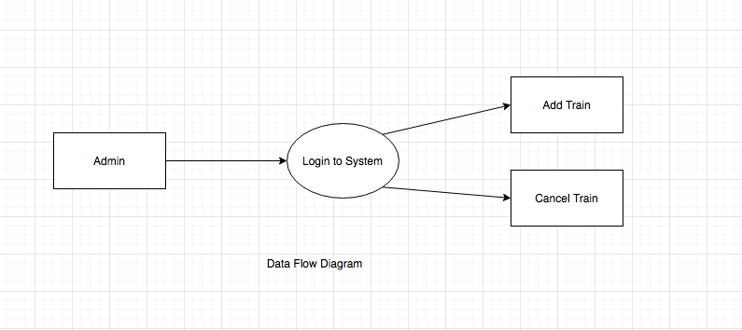

Figure 4.1 Data Flow Diagram Level 1

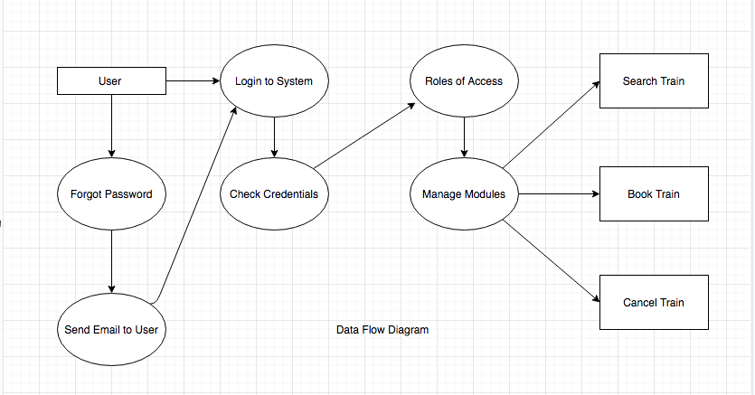

Figure 4.2 Data Flow Diagram Level 2

**4.2 USE CASE DIAGRAM**

**Admin**

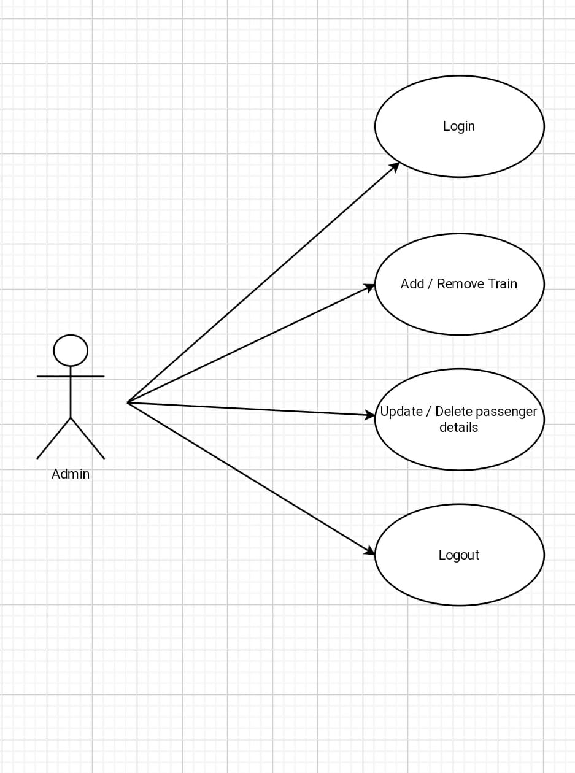

**5. IMPLMENTATION**

**5.1 CODE:**

<%@ Master Language="C#" AutoEventWireup="true" CodeBehind="Site1.master.cs" Inherits="mini_project.Site1" %>

<!DOCTYPE html>

<html xmlns="http://www.w3.org/1999/xhtml">

<head runat="server">

<link rel="stylesheet" href="https://cdn.jsdelivr.net/npm/bootstrap-icons@1.3.0/font/bootstrap-icons.css">

<script src="https://use.fontawesome.com/5536167179.js"></script>

<link rel="stylesheet" href="https://cdnjs.cloudflare.com/ajax/libs/font-awesome/4.7.0/css/font-awesome.min.css"/>

<link rel="stylesheet" href="https://stackpath.bootstrapcdn.com/bootstrap/4.4.1/css/bootstrap.min.css" integrity="sha384-Vkoo8x4CGsO3+Hhxv8T/Q5PaXtkKtu6ug5TOeNV6gBiFeWPGFN9MuhOf23Q9Ifjh" crossorigin="anonymous"/>

<link href="css/logo.css" rel="stylesheet" />

<script src="https://kit.fontawesome.com/840b1ebd19.js" crossorigin="anonymous"></script>

<link href="https://fonts.googleapis.com/css2?family=Heebo:wght@700&display=swap" rel="stylesheet">

<link href="https://fonts.googleapis.com/css2?family=Pacifico&display=swap" rel="stylesheet">

<title>Railway Reservation System</title>

<asp:ContentPlaceHolder ID="head" runat="server">

</asp:ContentPlaceHolder>

<style>

#a{

color:black;

font-weight:bold;

}

#data {

height:auto;

width:auto;

}

a,i {

display:inline-block;

}

</style>

</head>

<body>

<form id="form1" runat="server">

<nav class="navbar navbar-expand-lg navbar-light fixed-top "style="background-color: white">

<a class="navbar-brand" href="#">

<div style="background-color: #6351ce;">

<div class="container">

<!-- Grid row-->

<div class="row py-4 d-flex align-items-center">

<!-- Grid column -->

<div class="col-md-6 col-lg-5 text-center text-md-left mb-4 mb-md-0">

<h6 class="mb-0">Get connected with us on social networks!</h6>

</div>

<!-- Grid column -->

<!-- Grid column -->

<div class="col-md-6 col-lg-7 text-center text-md-right">

<!-- Facebook -->

<a href="https://www.facebook.com/assanhaigroup/?ref=aymt_homepage_panel&eid=ARBFc0ZyQpHI0jntU3MNbaAsCOl18y_QCuOUFfE6gkFwwud65KTw87HCbSLPAUFofHzy357i4Hu62SiU" class="fa fa-facebook"></a>

<!-- Twitter -->

<a href="https://twitter.com/vivek7678856091?fbclid=IwAR0erKBiyLBgKnjAIU2G-hQ1NwLGqPsvIZUfDASh3MndNaZb2a6xx-HoMKA" class="fa fa-twitter"></a>

<!-- Google +-->

<a href="http://vivekpandeyresume.000webhostapp.com/" class="fa fa-google"></a>

<!--Linkedin -->

<a href="#" class="fa fa-linkedin"></a>

<!--Instagram-->

<a href="#" class="fa fa-instagram"></a>

<a href="#" class="fa fa-youtube"></a>

</div>

<!-- Grid column -->

</div>

<!-- Grid row-->

</div>

</div>

<!-- Footer Links -->

<div class="container text-center text-md-left mt-5 bg-dark text-primary" >

<!-- Grid row -->

<div class="row mt-3">

<!-- Grid column -->

<div class="col-md-3 col-lg-4 col-xl-3 mx-auto mb-4">

<!-- Content -->

<h6 class="text-uppercase font-weight-bold">Indian railwayss</h6>

<hr class="deep-purple accent-2 mb-4 mt-0 d-inline-block mx-auto" style="width: 60px;"/>

<p>Welcome to Indain railwayss platform you can access all train detail and ticket booking very easy way and also check PNR status very easy way.</p>

<!-- Links -->

<h6 class="text-uppercase font-weight-bold">Contact</h6>

<hr class="deep-purple accent-2 mb-4 mt-0 d-inline-block mx-auto" style="width: 60px;"/>

<p>

<i class="fas fa-home mr-3"></i> banglore, karnatka, India</p>

<p>

<i class="fas fa-envelope mr-3"></i> rrs@gmail.com.com</p>

<p>

<i class="fas fa-phone mr-3"></i> + 01 234 567 88</p>

<p>

<i class="fas fa-print mr-3"></i> + 01 234 567 89</p>

</div>

<!-- Grid column -->

</div>

<!-- Grid row -->

</div>

<!-- Footer Links -->

<!-- Copyright -->

<div class="footer-copyright text-center py-3">© 2020-2021 Copyright:

<a href="my.php">Railway Reservation System</a>

</div>

</footer>

</div>

</center>

</form>

<script src="https://code.jquery.com/jquery-3.4.1.slim.min.js" integrity="sha384-J6qa4849blE2+poT4WnyKhv5vZF5SrPo0iEjwBvKU7imGFAV0wwj1yYfoRSJoZ+n" crossorigin="anonymous"></script>

<script src="https://cdn.jsdelivr.net/npm/popper.js@1.16.0/dist/umd/popper.min.js" integrity="sha384-Q6E9RHvbIyZFJoft+2mJbHaEWldlvI9IOYy5n3zV9zzTtmI3UksdQRVvoxMfooAo" crossorigin="anonymous"></script>

<script src="https://stackpath.bootstrapcdn.com/bootstrap/4.4.1/js/bootstrap.min.js" integrity="sha384-wfSDF2E50Y2D1uUdj0O3uMBJnjuUD4Ih7YwaYd1iqfktj0Uod8GCExl3Og8ifwB6" crossorigin="anonymous"></script>

</body>

</html>

**5.2 SNAPSHOTS**

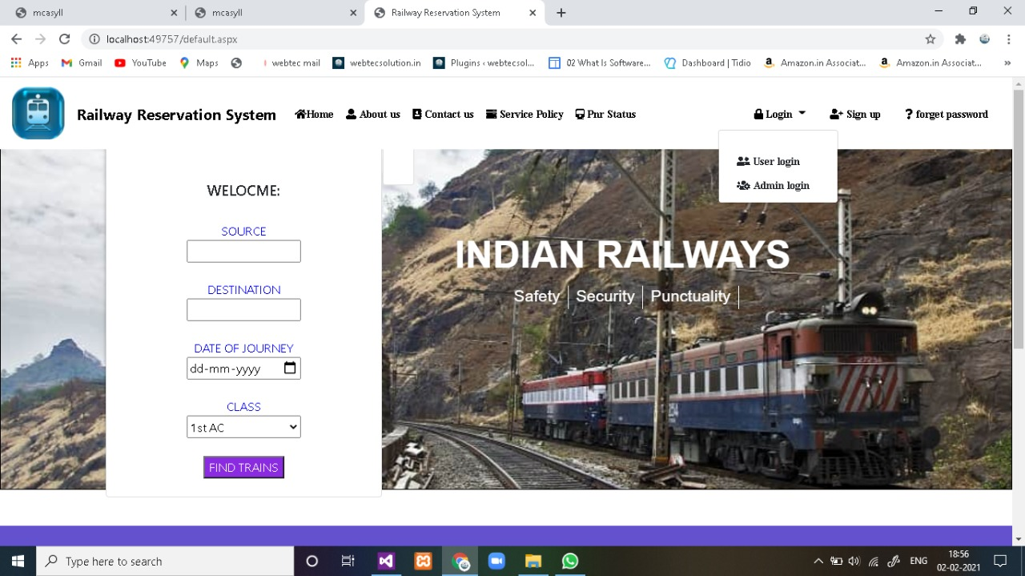

Figure 5.2.1 Home Page

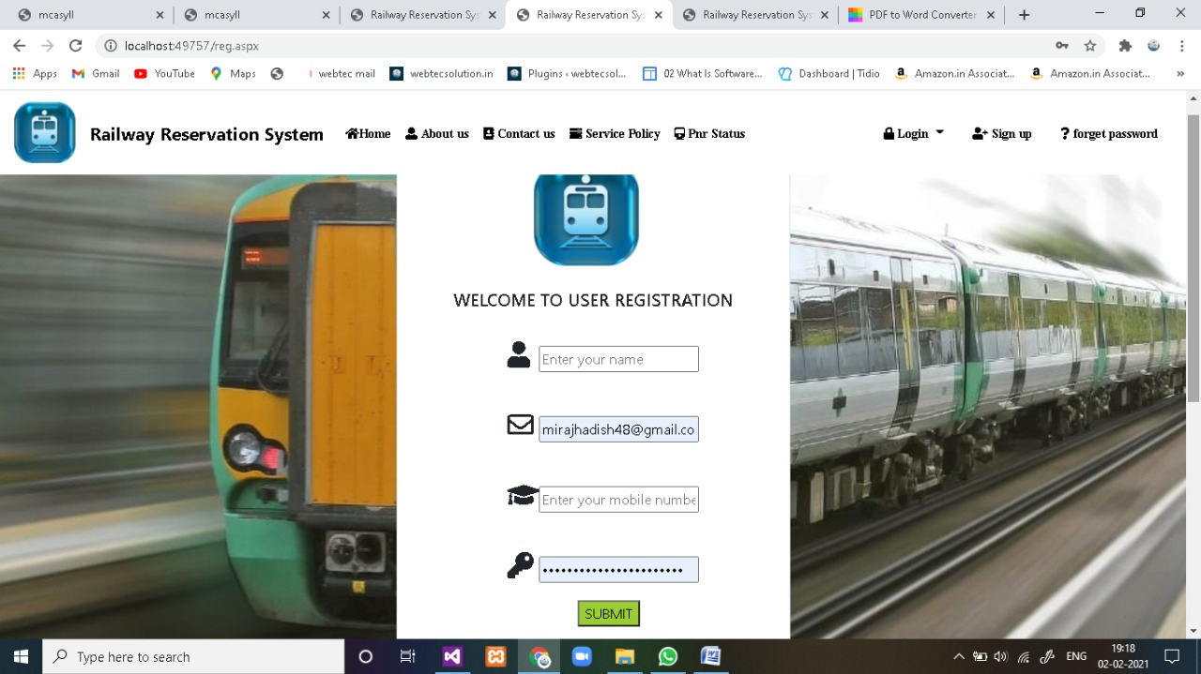

Figure 5.2.2 Registration

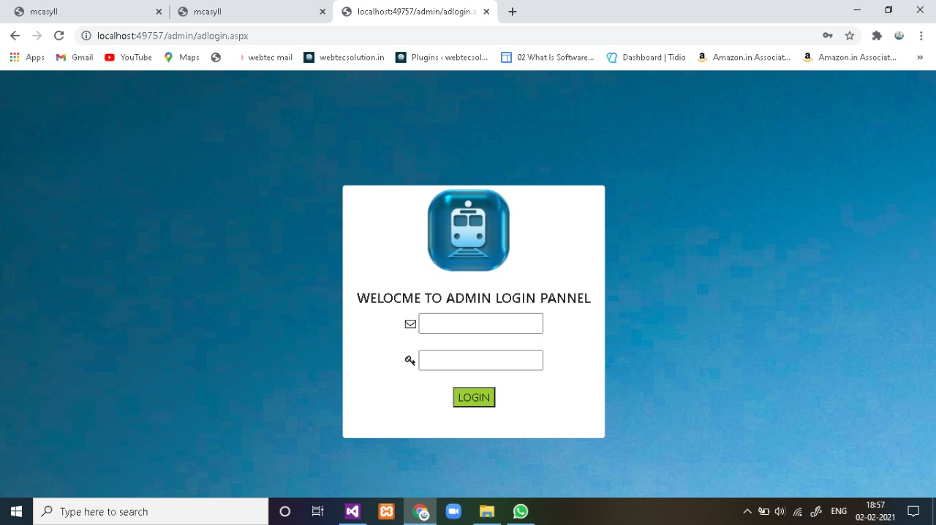

Figure 5.2.3 Admin

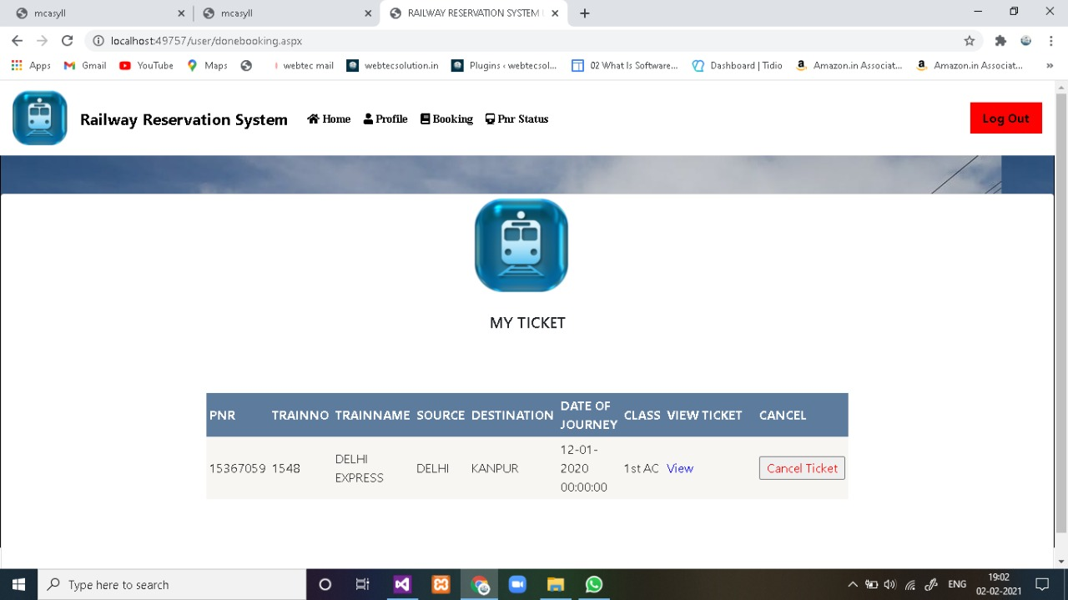

Figure 5.2.4 User Booking

**6. SOFTWARE TESTING**

**6.1. INTRODUCTION**

Software testing is an investigation conducted to provide stakeholders with information about the quality of the software product or service under test. Software testing can also provide an objective, independent view of the software to allow the business to appreciate and understand the risks of software implementation. Test techniques include the process of executing a program or application with the intent of finding software bugs (errors or other defects), and verifying that the software product is fit for use.

**6.2. PURPOSE**

Software testing involves the execution of a software component or system component to evaluate one or more properties of interest. In general, these properties indicate the extent to which the component or system under test:

• meets the requirements that guided its design and development,

• responds correctly to all kinds of inputs,

• performs its functions within an acceptable time,

• it is sufficiently usable,

• can be installed and run in its intended environments, and

• achieves the general result its stakeholders desire.

**6.3. TESTING METHODS**

**• Unit Testing**

Testing of an individual software component or module is termed as Unit Testing. It is typically done by the programmer and not by testers, as it requires a detailed knowledge of the internal program design and code. It may also require developing test driver modules or test harnesses.

**• System Testing**

Under System Testing technique, the entire system is tested as per the requirements. It is a Black-box type testing that is based on overall requirement specifications and covers all the combined parts of a system

•**Integration Testing**

Integration testing is a level of software testing where individual units are combined and tested as a group. the purpose of this level of testing is to expose faults in the interaction between integrated units. test drivers and test stubs are used to assist in integration testing.

•**Acceptance Testing**

Acceptance testing is a level of software testing where a system is tested for acceptability. The purpose of this test is to evaluate the system’s compliance with the business requirements and assess whether it is acceptable for delivery.

•**White-box testing**

White-box testing (also known as clear box testing, glass box testing, transparent box testing, and structural testing) verifies the internal structures or workings of a program, as opposed to the functionality exposed to the end-user. In white-box testing, an internal perspective of the system (the source code), as well as programming skills, are used to design test cases. The tester chooses inputs to exercise paths through the code and determine the appropriate outputs. This is analogous to testing nodes in a circuit, e.g., in-circuit testing (ICT).

•**Black-box testing**

Black-box testing (also known as functional testing) treats the software as a "black box," examining functionality without any knowledge of internal implementation, without seeing the source code. The testers are only aware of what the software is supposed to do, not how it does it.

**7. CONCLUSION**

Rather than designing manually we have made use of computer as once that data s are input it performs accurate function. There is no’ chance of fault or miscalculation if the data are feeded correctly. Use of the computers has solved many problems, which are faced while manual calculation. This is not the end but beginning of the versatile, efficient and outsourcing railway reservation system. This is the one which is compatible to all operating system. By making this project we made a small footstep towards the path of progress of platform independent railway reservation system. After successful implementation of Railway Reservation System, it will help to the management for managing task efficiently. This gives satisfactory outputs as per required by the End User. This system also has extensibility feature that allows the Users to fulfill their additional requirements in the current system. After testing, the system gives same outputs as expected. Railway Reservation System is made economically, technically sound, and providing Efficiency.

**8. FUTURE ENHANCEMENT**

This project is currently running on the local server, as soon as we take the web API of the railway, we will make it live completely.This project has been designed by looking at the current situation. We will use ADHAR data fetching techniques as soon as possible in the future, which is not being used in real time in Irctc.

**9. BIBLIOGRAPHY**

[www.w3](http://www.w3) schools.com

www.slideshare.com

www.scribd.com